19th October 2023
Dear Parent of ___________________________ ,

Your child has shown an interest in joining the VEX robotics team and has successfully gained a place in the free afterschool club for this academic year.

VEX Robotics Team
Wednesday 3 – 4pm starting 1.11.23 until further notice.
Cost = FREE!

There are very limited places so please let me know immediately if your child can or cannot attend.
Please see below the format of how your child will be involved in this club:
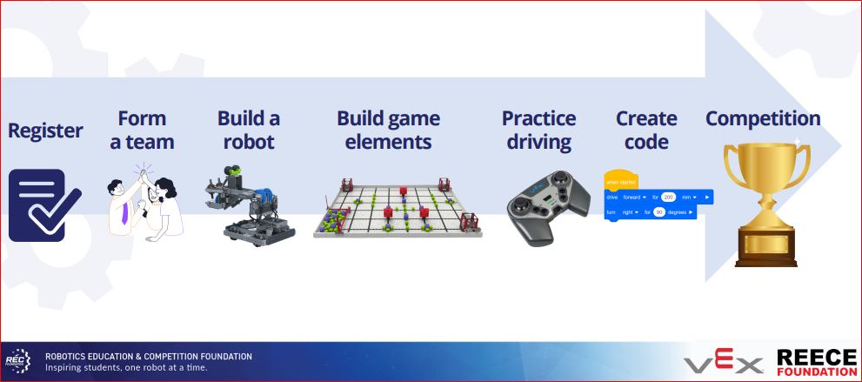

Competitions will be held at Nissan and may take place out of school hours depending on how successful our robotics team perform. Further details of competitions will be sent out in due course.

Yours sincerely,

Mrs Page

Robotics Club – Wednesday 3-4pm

My child _________________________________ Class ____ would like a place in the above after-school club.

I will collect them from Cortina Avenue [ ] Walk home themselves [ ]

Signed: _____________________________________________________ (parent/carer)

Print name: __________________________________________________ (parent/carer)

Date: _________________ Telephone number: __________________________________

