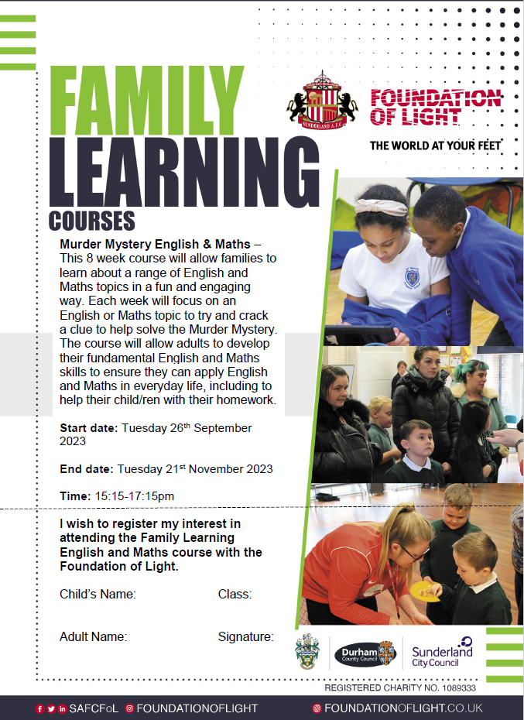

**Start Date:** Tuesday 10th October

**End Date:** Tuesday 5th December

**Time:** 1:00 – 3:00pm

**Venue:** Broadway Family Learning Room