January 2024
Dear Parent/Carer,

We are delighted that we have been able to secure a visit to Derwent Hill for next year’s Year 6 children. The Year 6 residential to Derwent Hill is Monday 16th September 2024 to Friday 20th September 2024. This will be a great opportunity for the Year 6 teachers to develop brilliant relationships with the children, getting their final year at Broadway off to a great start.

The cost of the trip is £240. We are subsidising the total cost of the trip as much as we are able to.

If you would like to reserve a place for your child, please return the attached form before Friday 26th January 2024. You will then be sent a link to pay a £10 deposit on School Money. Please pay this deposit before Friday 2nd February 2024.

As Derwent Hill operates like a travel agency, booking conditions and cancellation fees apply. Therefore, once you return the attached form and pay the £10 deposit, you are committing to the place for your child and agreeing to the following payment and cancellation conditions:

Derwent Hill Cancellation Conditions and Charges
If you cancel your child’s place: | You will need to pay:
Any date from the day you pay your deposit until Thursday 6th June 2024 | £60 (25% of the total cost)
Between Friday 7th June 2024 to Friday 5th July 2024 | £120 (50% of the total cost)
After Friday 5th July 2024 | £240 (100% of the total cost)

In the event that you wish to cancel your child’s place, we are unfortunately unable to refund any money and will require the payment as stated above. Therefore, please ensure that your child is absolutely certain that they want to go before you commit to paying the deposit.

If the cost of the trip is going to prevent your child from taking part, please get in touch with us to see if we can help at all.

Yours sincerely,
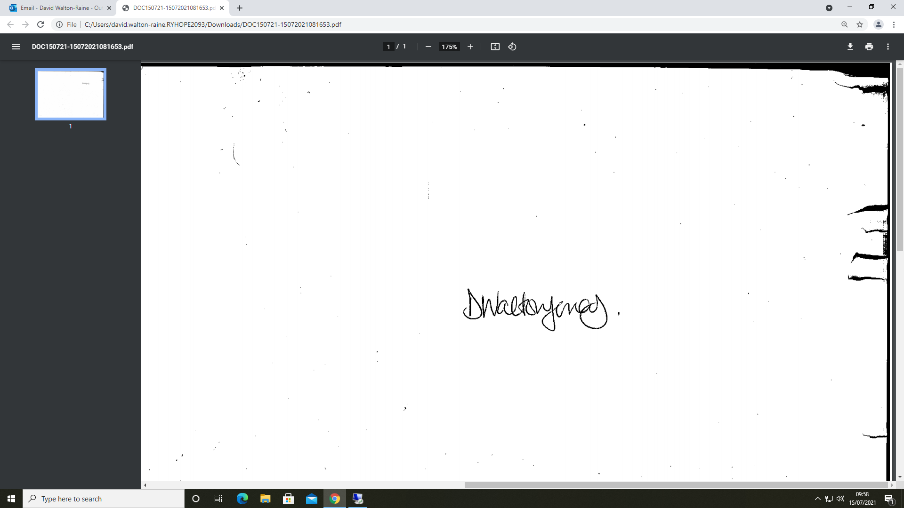

Mr. D. Walton-Jonas
Headteacher

